**Phase 1 Practice Project – Assisted Practice**

**1 . Write a program in java to create a thread by extending ‘Thread’ class**

**And by implementing the “Runnable” interface.**

**Source Code:**

package Threads;

import java.io.*;

import java.lang.*;

public class A extends Thread{

public void run() {

for(int i=1; i<=5; i++) {

System.out.println(i);

}

System.out.println("Exit from A");

}

public static void main(String[] args) {

A a = new A();

a.start();

}

}

**Output:**

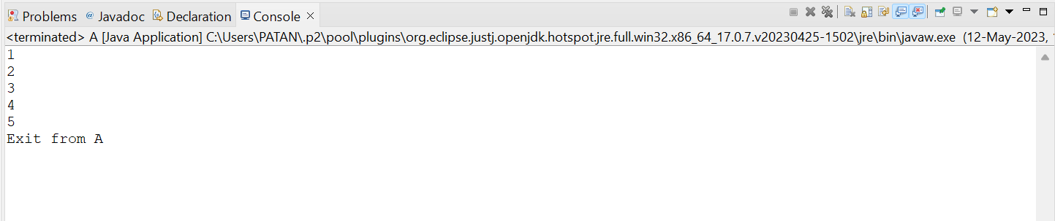

**By using Runnable Interface**

**Source Code:**

package Threads;

import java.io.*;

import java.lang.*;

public class B implements Runnable{

public void run() {

for(int i=1; i<=10; i++) {

System.out.println(i+ "\t");

}

System.out.println("Exit From A");

}

public static void main(String[] args)

{

B b = new B();

Thread t = new Thread(b);

t.start();

}

}

**Output:**

